Smart Home Automation
IOT
By- Tec Santosh Kumar
Department of Electrical and Electronics Engineering
SR Group of Institutions Lucknow
Date: 27th November 2020

Abstract: The idea behind Smart Home automation Using IOT is to control home devices with voice, Manually, App, and Web. On the market there are many devices available to do that, but making our own is awesome. In this project, the Google assistant requires or Alexa voice commands. Adafruit account which is a cloud based free IoT web server used to create virtual switches, is linking to IFTTT website abbreviated as “If This Than That” which is used to create if else conditional statements. The voice commands for Google assistant or Alexa have been added through IFTTT website. In this Smart home automation, as the user gives commands to the Google assistant, Alexa A Home appliances like Bulb, Fan, Water Pump, AC, Cooler, Door, and Motor etc., can be controlled accordingly. The commands given through the Google assistant and Alexa are decoded and then sent to the microcontroller, the microcontroller in turn control the relays connected to it. The device connected to the respective relay can be turned On or OFF as per the users request to the Google Assistant and Alexa. The microcontroller used is NodeMCU (ESP8266) and the communication between the microcontroller and the application is established via Wi-Fi (Internet).

CHAPTER - 1 INTRODUCTION

1.1 HOME AUTOMATION
“Home automation” refers to the automatic and electronic control of household features, activities, and appliances. The utilities and features of our home can be easily controlled via Internet. There are three main elements of a home automation system: sensors, controllers, and actuators.

Having day to day developing technology is a proud moment to the whole world. The foremost aim of the technology is to increase the efficiency and to decrease the effort. In this trending world, Internet of Things is being given extreme importance. In that, Automation, leads to have less effort and much efficiency. By using IoT, we are successful in controlling the appliances in various areas, in which one of them is to control the home automation by using Node Microcontroller. We can also use other boards like raspberry pi, beagle bone etc., In the present-day technology, the whole work is done through communication so the effective way of communication can be done through voice.
Even though the technology is developing in our day to day life, there is no help coming into existence for the people who are physically not good on the basis of technology. As the speech enabled, home automation system deploys the use of voice to control the devices. It mainly targets the physically disabled and elderly persons. The home automation will not work if the speech recognition is poor. The speech given by the user will be given as input to the Microphone. Microphone recognizes the speech given by the person and sends it to the recognizing module. It searches for the nearest word even if there are any disturbances in it. If the command (ON/OFF) is given, the action is done. Similarly, the line following robot functions with respect to the speech commands given to it. The line following robot moves forward and backward with the help of sensors and a motor driver board.
Home is the place where one desires to be rest after a long tiring day. People come home exhausted after a long hard-working day. Some are way too tired that they find it hard to move once they land on their couch, sofa or bed. So, any small device/technology that would help them switch theirs lights on or off, or play their favorite music etc. on a go with their voice with the aid of their smart phones would make their home more comfortable. Moreover, it would be better if everything such as warming bath water and adjusting the room temperature were already done before they reach their home just by giving a voice command. So, when people would arrive home, they would find the room temperature, the bath water adjusted to their suitable preferences, and they could relax right away and feel cozier and rather, feel more homely. Human assistants like housekeepers were a way for millionaires to keep up their homes in the past. Even now when technology is handy enough only the well to do people of the society are blessed with their new smart home devices, as these devices costs are a bit high. However, not everyone is wealthy enough to be able to afford a human assistant, or some smart home kit. Hence, the need for finding an inexpensive and smart assistant for normal families keeps growing.

1.2 INTERNET OF THINGS
The major concept using in the Google assistant and Alexa-controlled Smart Home automation is the Internet of Things. The Internet of Things (IoT) can be connecting various types of objects like smart phones, personal computer and tablets to the internet, which brings new-fangled type of communication between things and things, and things and people. The Fig 1.1 shows the Home automation system.

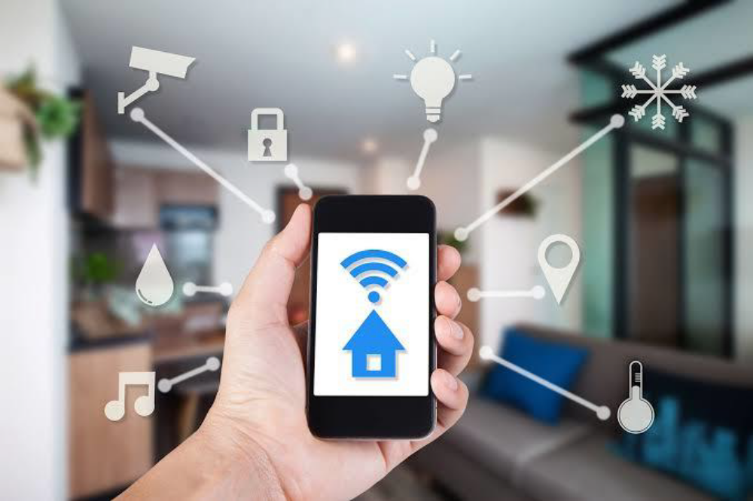
Fig. 1.1 Home automation system

Any man-made objects that can be assigned an IP address and it has the ability to transfer data successfully over a network, the interaction through a network is called IoT. The internet helps us to bring immediate solutions for many problems and able to connect from any of the remote places. The Internets of Things technology is used to come in with innovative idea and large development space for smart homes to improve the living standards of life. The growth of the Internet of Things will reform a number of sectors, like healthcare, automation energy, transportation, etc. The cloud computing can be used in such case to implement the IoT infrastructure that augmented with sensors and actuators to monitor and control “things” from anywhere.

1.3 BASIC APPLICATIONS OF HOME AUTOMATION
Remote home monitoring allows users to manage and control various aspects of home. These include motion detection, water leak detection, monitoring temperature against burglary and fire, and controls for lights, locks, fans and more from Laptop or Tablet or Smartphone. The household activities are automated by the development of special appliances such as water heaters to reduce the time taken to boil water for bathing and automatic washing machines to reduce manual labor of washing clothes. In developed countries, homes are wired for electrical power, doorbell, TV outlets, and telephones. The different application includes when a person enters the room, the light turns on. In advanced technology, the room can sense the presence of the person and who the person is. Taking into account the day of the week, time of the day and other such factors it can also set apt lighting, temperature levels, television channels or music levels. In the case of a smoke detector when fire or smoke is detected, the lights in the entire house begin to blink to alert the resident to the probable fire. In case of a home theatre, the home automation system can avoid distraction and lock the audio and video components and can also make an announcement. The home automation system can also dial up the house owner on their mobile phone to alert them or call any alarm monitoring company. It is essential that the different controllable appliances be interconnected and communicate with each other. The basic aim of Home automation is to control or monitor signals from different appliances, or basic services. A smart phone or web browser can be used to control or monitor the home automation system. The household

1.4 AN INTRODUCTION TO THE ARCHITECTURE
The hardware architecture of this system consists of Node MCU and smartphone. The wireless communication between the smartphone and the Node MCU is done over the Internet. Android OS has a built-in voice recognizing feature named Google assistant which is used to develop a smartphone application which has ability to control the home appliances from user voice command. This application converts the user voice command into text, then it transmit that text message to Adafruit libraries which is connected with Node MCU through IFTTT website which is abbreviated as IF THIS THAN THAT and is a website used to create a simple chain of conditional statements called applets. One advantage of voice-controlled home automation system is that user only pronounce the appliance name in smartphone microphone and telling it to switch ON or OFF the appliances, in this way the users can control home appliance easily without any effort. A voice recognition application provided a user-friendly interface to users and it has ability to add more home appliances into the system. This home automation system can be used in every building using electrical appliances and devices.
The main drawback of system is that it is failed to work efficiently in a noisy environment. The main advantage is that its range can be extended as we are using Internet instead of Bluetooth as Bluetooth has the limited range but this solution will not be cost effective. Another advantage of using Google assistant-controlled Home automation is that it is totally of wireless communication as many existing system Home automation is based on wired communication.

CHAPTER – 2 LITERATURE REVIEW & PROBLEM
IDENTIFICATION

2.1 INVENTIONS TO HOME AUTOMATION
When people think about home automation, most of them may imagine living in a smart home: One remote controller for every household appliance, cooking the rice automatically, starting air conditioner automatically, heating water for bath bring out smart living condition and make our life more convenient and faster. Early home automation began with labor-saving machines. Self-contained electric or gas-powered home appliance became viable in the 1900s with the introduction of electric power distribution led to the introduction of washing machine (1904), water heater (1889), refrigerator, sewing machines, dishwashers and clothes dryers. Currently there exists system neither at cheaper rates nor easy to handle. Various systems are hard to install, difficult to use and maintain. Current systems are generally proprietary, closed and not very user friendly Based on Arduino or GSM or low-cost home security system and home automation system.

2.2 LITERATURE REVIEW
Tan, Lee and Soh (2002) proposed the development of an Internet-based system to allow monitoring of important process variables from a distributed control system (DCS). It proposes hardware and software design considerations which enable the user to access the process variables on the DCS, remotely and effectively rent designations. Potamitis, Georgila, Fakotakis, and Kokkinoss, G. (2003) suggested the use of speech to interact remotely with the home appliances to perform a particular action on behalf of the user. The approach is inclined for people with disability to perform real-life operations at home by directing appliances through speech. Voice separation strategy is selected to take appropriate decision by speech recognition. In the year 2006, S. M. Anamul Haque, S. M. Kamruzzaman and Md. Ashraful Islam proposed a system entitled “A System for Smart-Home Control of Appliances Based on Time and Speech Interaction” that controls the home appliances using the personal computer. This system is developed by using the Visual Basic 6.0 as programming language and Microsoft voice engine tools for speech recognition purpose. Appliances can be either controlled by timer or by the voice command. Jawarkar, Ahmed, Ladhake, and Thakare (2008) propose remote monitoring through mobile phone involving the use of spoken commands. The spoken commands are generated and sent in the form of text SMS to the control system and then the microcontroller on the basis of SMS takes a decision of a particular task. Prof. Era Johri in (2001) have successfully completed the project on “Remote Controlled Home Automation”.
Withings is a consumer electronics company is the leader in the connected health revolution. The Home camera alerts the user to many motion or noise while out of the House. It also tracks the indoor air quality, notifying the user if dangerous levels of voltaic organic compounds are detected. It has taken security, privacy and home health to the next level through a partnership with IFTTT, a service that allows rule-based actions and triggers between a range of devices and services. Users can enhance their Withings Home, a HD security camera equipped with environmental sensors, by connecting with IFTTT app to make household automation a reality. Fig 2.1 shows the Reality Home automation explaining that if the user is leaving the home, then the camera inserted to monitor automatically starts to watch. 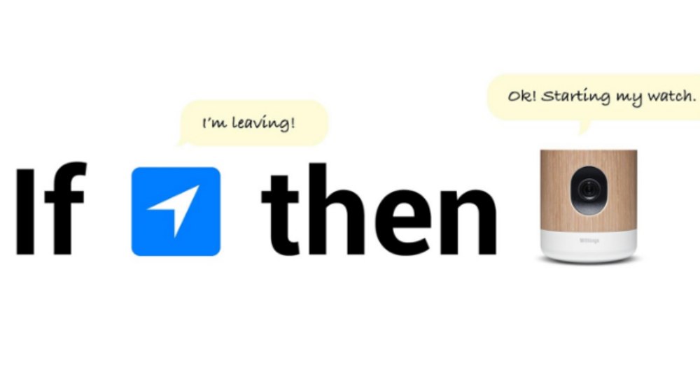
Fig 2.1 Reality Home automation

The comprehensive Home monitoring solution was first presented at Consumer Electronics Show in 2014. Withings Home is one of the most comprehensive home monitoring solutions on the market, allowing users to stay connected to their home and family from anywhere. The camera can be used with the IFTTT app to create a number of recipes between connected services and the camera, such as turning it on when user’s phone is using geolocation or when the door is locked, or making it turn on the air purifier when bad quality is detected. Parents can take comfort in having superior features such as Baby Monitor Mode, which has continuous monitoring, alerts and interactive push-to-talk. One of the topics which is gaining popularity of Home Automation System is because of its innumerous advantages. Home automation refers to the monitoring and controlling of home appliances remotely. with the never-ending growth of the Internet and its applications, there is much potential and scope for remote access and control and monitoring of such network enabled appliances. The effort targeted on the home automation concept of where the controlling and monitoring operations are expediting through smart devices. Wide-ranging home automation systems and technologies considered in review with central controller based (Arduino or Raspberry pi), cloud-based, Bluetooth-based, SMS based, ZigBee based, mobile-based, RF Module based, web based and the Internet with performance. A microprocessor, sometimes called a logic chip, is a computer processor on a microchip. The microprocessor contains all, or most of, the central processing unit (CPU) functions and is the "engine" that goes into motion when the computer turns on.
A microcontroller is a control device which incorporates a microprocessor. It is a compact integrated circuit designed to govern a specific operation in an embedded system. A typical microcontroller includes a processor, memory and input/output (I/O) peripherals on a single chip. The NodeMCU (Node MicroController Unit) is an open source software and hardware development environment that is built around a very inexpensive System-on-a-Chip (SoC) called the ESP8266. Key difference in both of them is presence of external peripheral, where microcontrollers have RAM, ROM, EEPROM embedded in it while we have to use external circuits in case of microprocessors. As all the peripheral of microcontroller are on single chip it is compact while microprocessor is bulky.

2.4 EXISTING METHOD
A home automation system allow users to control electric appliances of varying kind. Many existing, well established home automation systems are based on wired communication. This does not pose a problem until the system is planned well in advance and installed during the
One of the most important Hardware requirements of the project is Node Microcontroller. To understand more about it, one must know about Microprocessors and Microcontrollers and also the differences between them.

2.3 MICROPROCESSOR AND MICROCONTROLLER
A microprocessor is a computer processor that incorporates the functions of a central processing unit on a single integrated circuit (IC), or at most a few integrated circuits. A microprocessor, sometimes called a logic chip, is a computer processor on a microchip. The microprocessor contains all, or most of, the central processing unit (CPU) functions and is the "engine" that goes into motion when the computer turns on.
A microcontroller is a control device which incorporates a microprocessor. It is a compact integrated circuit designed to govern a specific operation in an embedded system. A typical microcontroller includes a processor, memory and input/output (I/O) peripherals on a single chip. The NodeMCU (Node MicroController Unit) is an open source software and hardware development environment that is built around a very inexpensive System-on-a-Chip (SoC) called the ESP8266. Key difference in both of them is presence of external peripheral, where microcontrollers have RAM, ROM, EEPROM embedded in it while we have to use external circuits in case of microprocessors. As all the peripheral of microcontroller are on single chip it is compact while microprocessor is bulky.

2.4 EXISTING METHOD
A home automation system allow users to control electric appliances of varying kind. Many existing, well established home automation systems are based on wired communication. This does not pose a problem until the system is planned well in advance and installed during the physical construction of the building. IoT is a system that uses computers or mobile devices to control basic home functions and features automatically through Internet from anywhere around the world. Internet or IP protocol-based communication in home automation systems is always a popular choice. The capacity of a product or system to communicate in a standard way with other products or system is Interoperability. The existing system has a drawback that the graphical user interface (GUI) is not provided to the user and the user has to remember all the AT commands to control the connected devices. Also, the system uses the java-based functions. Now a days, the usage of those mobile has less. But in the proposed system we are controlling all devices through android mobile and web server and the user no need to remember the commands also. Some devices are automated like cooler, Fan, Light, Electric motor etc.

2.5 PROPOSED METHOD
The proposed system eliminates the complication of wiring in case of wired automation. Considerable amount of power supply is also possible. Operating range is more than the Bluetooth. The existing system does not allow remote monitoring and controlling of appliances. But where as in the proposed system the system using the Wi-Fi based home automation system it allows to monitor and control the appliances. The home automation of he existing system in 1990’s, the people in every home has electronic devices which are controlled manually but in our proposed system we are controlling all electronic appliances through remotely. The IOT application have become this popular in this 21st century is due to dominant use of the internet, evolution of smart phone technology and raised standard of mobile communication.

2.6 PROBLEMS OF HOME AUTOMATION
Wired or wireless systems, while in the house not very likely to face many problems. However, when controlling through the application locally or remotely, we can face problems such as delays in performance and that is frustrating. Delays could be due to poor internet connection and planning in the house. If we are having battery operated devices and their usage is more than normal, then battery problems could be another issue for what we to deal with and also the voice-recognition of Google assistant is not up-to the mark if there is noisy Environment. Due to Interference of the nearby noise, the Google assistant commands may also not work properly. Home Automation is still an expensive product, by Indian consumer standards, and there’s a lot of scope of the prices to be whittled down by an order of magnitude at least in the next few years. This will happen as more companies manufacture the key components of Automation systems (controllers, Gateways etc.,) and economies of scale takes over.

2.7 PROBLEMS RESOLVE USING HOME AUTOMATION DEVICES
Firstly, Home Automation will save time in daily recursive activities like turning of lights, geysers and other home appliances. Users don't need to think about whether the lights are turned off or did geyser or AC turned off or not while they are in office. Users can sit anywhere in the globe access our home away from home.
Secondly, security, users can secure their home while they are away from home. There are devices which keep monitoring the home and notify them when any incident occurs. The notification can be a simple SMS or a voice call which can alert and take necessary action. These devices can also run on Batteries. So need not worry about even when electricity is turned off.
Thirdly, Convenience, users don't need to manually go-to each and every room to see if any light or fan is switched on and turn off, instead they can on/ off all lights in a room or entire home. Users will have the convenience of controlling devices through smart phone or tablet.
The next one is Safety, in every home, situation arise when parents have to leave outstation and kids stay alone at home. In this scenario, Automation helps in securing kids’ safety. One can install surveillance cameras and keep monitoring through mobile from anywhere in the globe. Also, there are devices which won't allow to unlock the main door from outside once it is locked from inside. Also, Sensors can be placed outside which can turn on light automatically in the night if someone try to intrude into home. These are the main problems resolve using the Home automation devices. There are many more benefits from Home Automation.

CHAPTER – 3 METHODOLOGY

The methodology of this project design includes implementation of the proposed method. There are some basic steps involving in the Methodology of the product. The first major step is setting up the Adafruit IO. Adafruit IO is a website used to create virtual switches which will be turned ON or OFF depending on the commands given to the Google assistant and the second step is connecting the ESP8266 and the last step is connecting to Google assistant through IFTTT. IFTTT is also a website used to create simple chain of conditional statements for like if else statements. By following these three steps, the implementation of the proposed system is going to be done.

3.1 ADAFRUIT IO
First, create account at www.Adafruit.io
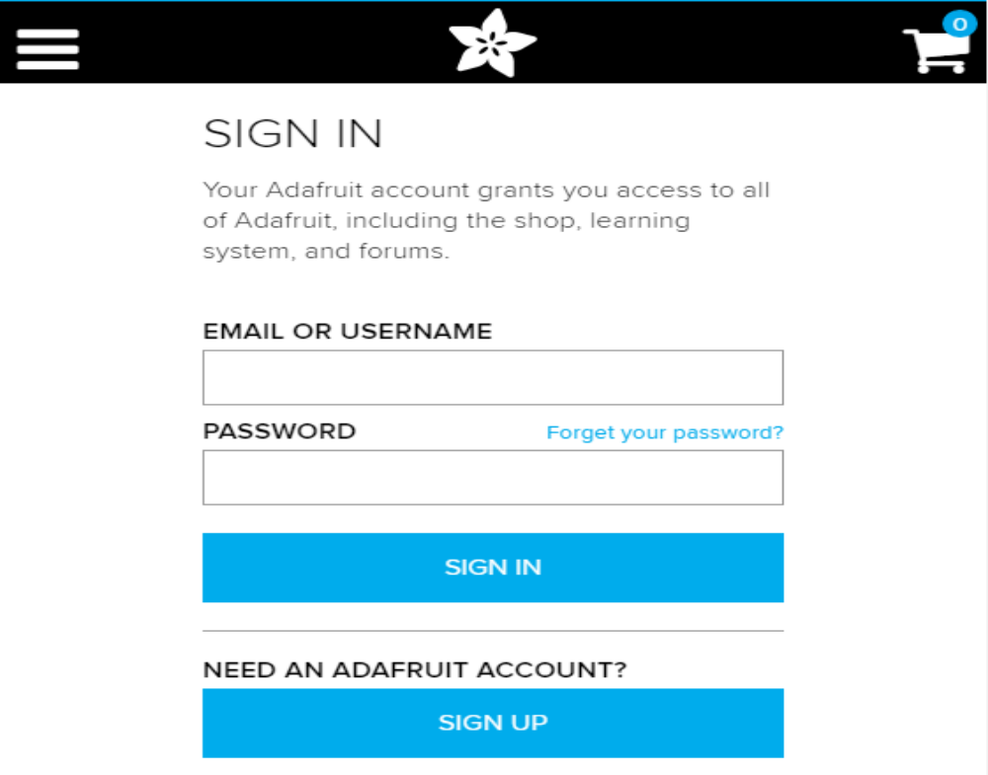
Fig 3.1 Adafruit Sign In page
Now, create dashboard at Adafruit. This dashboard is a user interface to control things remotely.
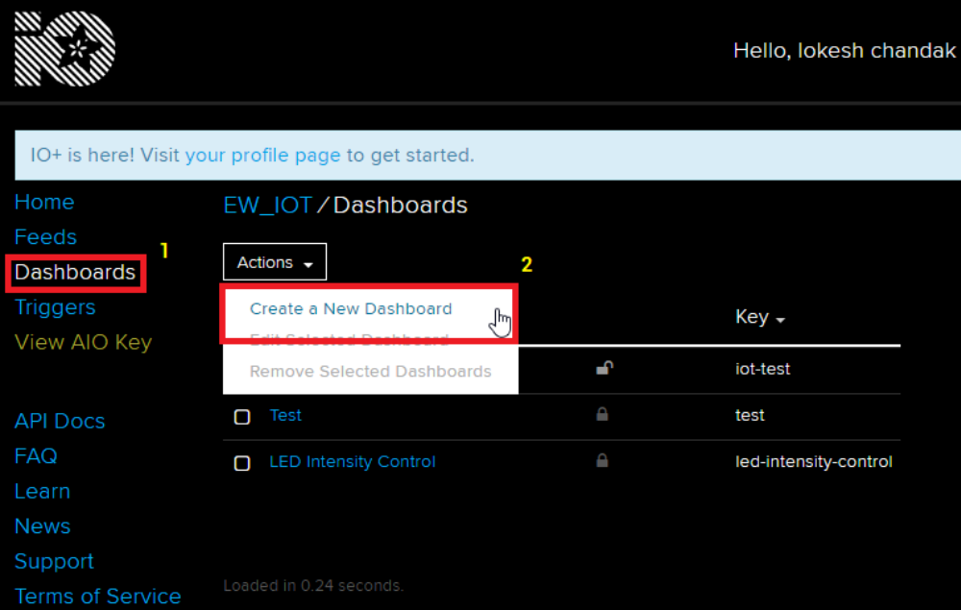
Fig 3.2 Creating a Dashboard

After following above steps, provide name to the dashboard and save it. Users can see their dashboard as follows,

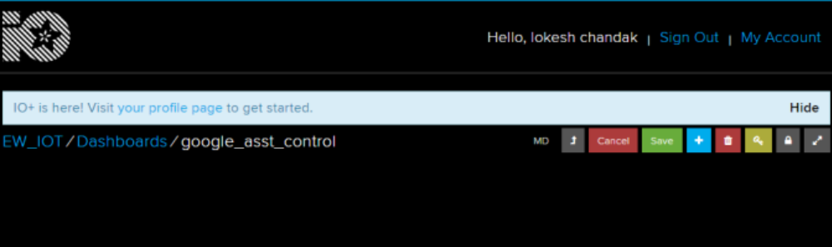
Fig 3.3 Dashboard after login

Now, create feed (user interface) to control light On-Off. To create it, just click on ‘+’ symbol and select toggle feed shown below,

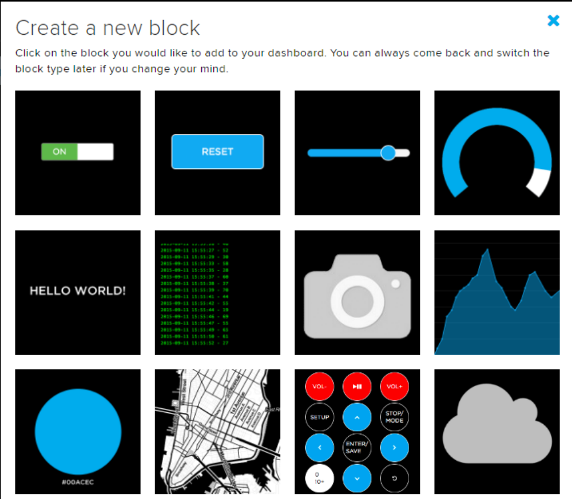
Fig 3.4 Creating blocks for switches

After selecting toggle feed, pop-up window appears as shown below.
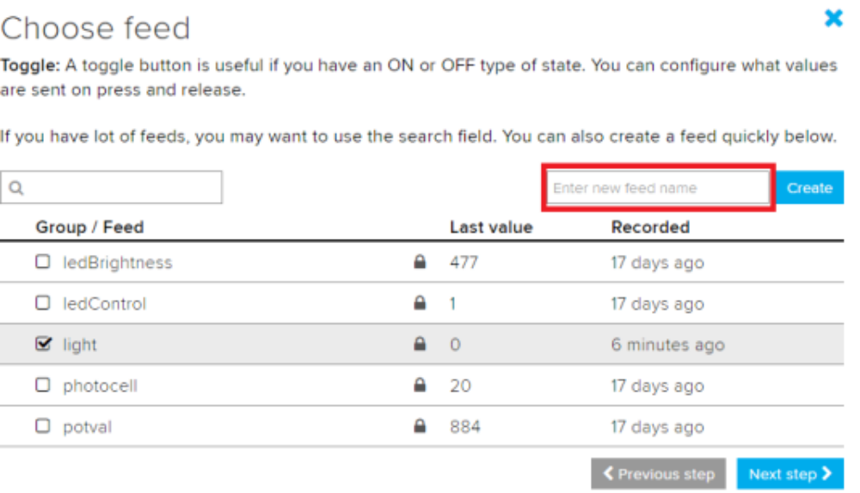
Fig 3.5 Choosing Feed in Dashboard
Enter name of our feed (shown in red box) and create it. After creation, select the created feed (here mine is light) and then click on Next step.
In the next step configure the feed which is shown below,

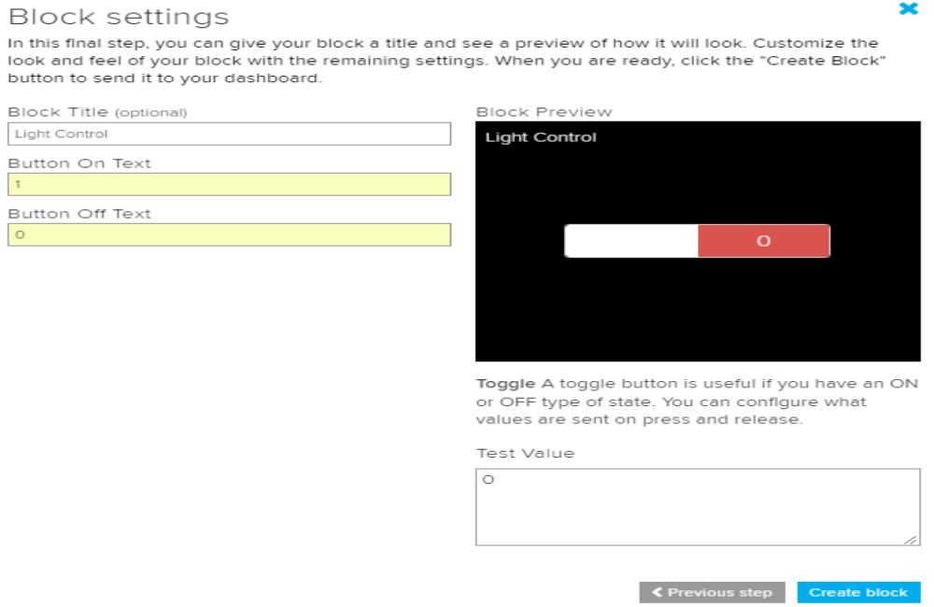
Fig 3.6 Block settings for turning ON and OFF

Here, 0 is used as (OFF) and 1 is used as (ON) text for button and then click on create. This will create toggle button on your dashboard which can be used to control things remotely.
Now, dashboard is ready for IoT application like home automation.
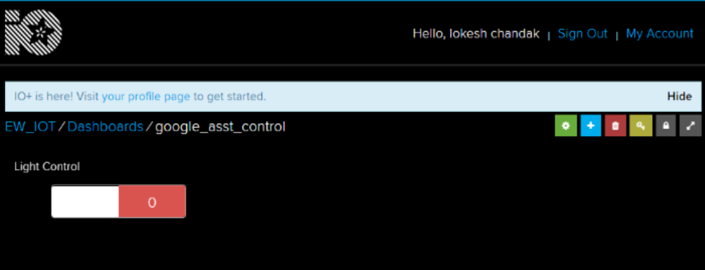
Fig 3.7 Creating Virtual switches in Dashboard

3.2 IFTTT (If This Then That)
If This Then That, also known as IFTTT is a free web-based service to create chains of simple conditional statements, called applets. An applet is triggered by changes that occur within other web services such as Gmail, Facebook, Telegram, Instagram, or Pinterest. For example, an applet may send an e-mail message if the user tweets using a hashtag or copy a photo on Facebook to a user's archive if someone tags a user in a photo.
Here, IFTTT is used to use google assistant service and Adafruit service in chain. So, Google assistant is used to control light of my home by saying Ok google, turn the light ON or OFF. Then IFTTT interpret the message and can send it to Adafruit’s dashboard as an understandable command to the created feed.
First step is creating account on IFTTT.
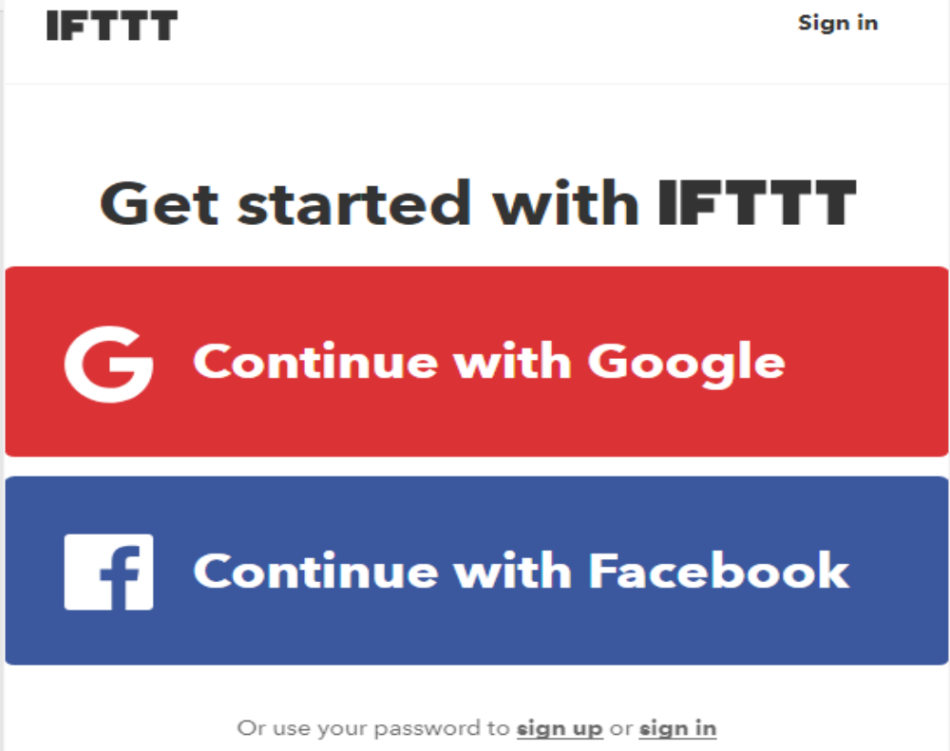
Fig 3.8 Creating account in IFTTT Website

Note: Create account on IFTTT by using same e-mail id which have been used for Adafruit.
After account creation, click on My Applets and then select New Applet shown below,
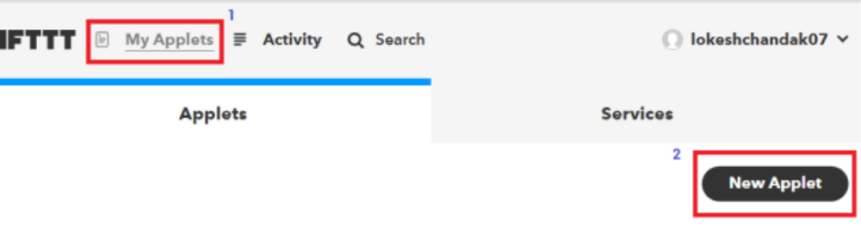
Fig 3.9 Applet creation in IFTTT website

After selecting a new applet, we get a new page in which we should click on to This as shown in Fig 3.10.

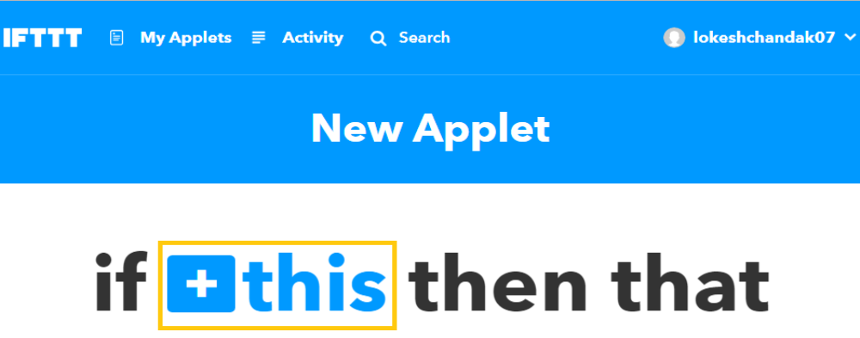
Fig 3.10 Creating IF THIS statement in IFTTT website

Then search for Google Assistant and select it.
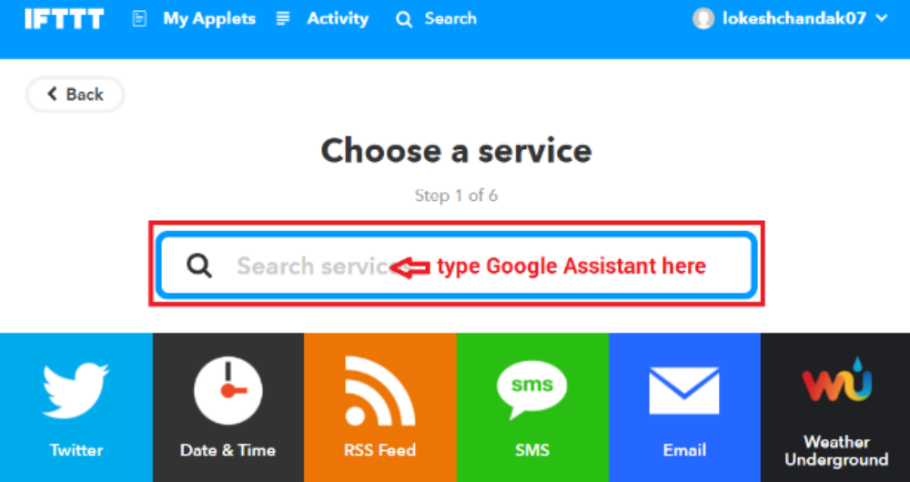
Fig 3.11 Searching Google assistant
Now, enter voice phrases which will be used as a command for google assistant.
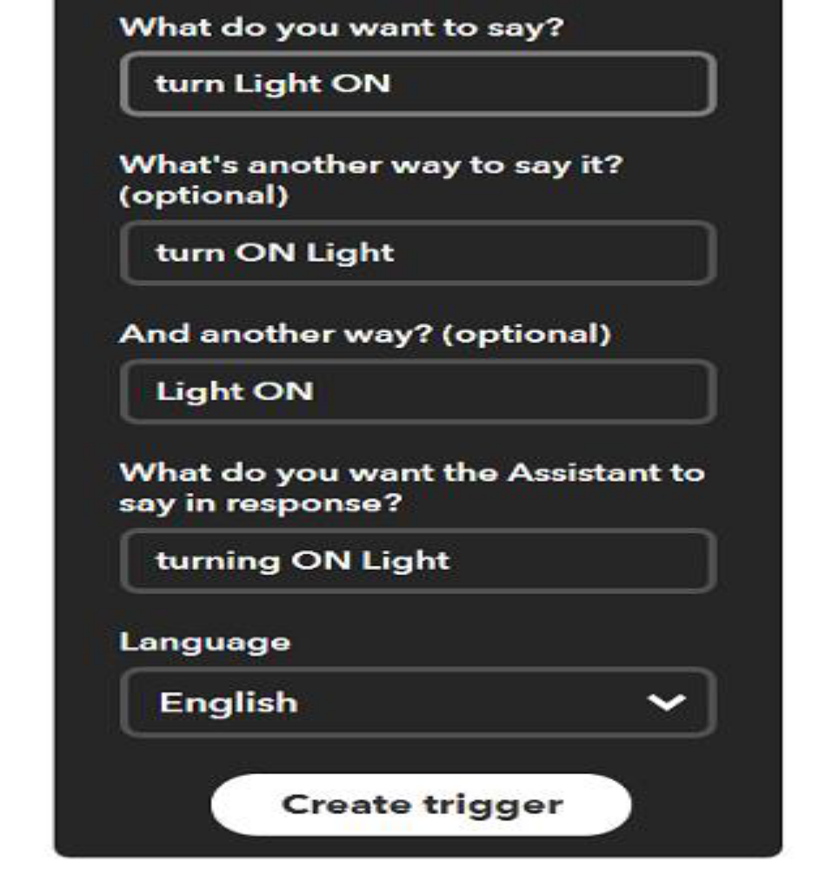
Fig 3.12 Creating Trigger

Any phrase can be entered as per the application. The phrases entered in the Fig 3.12 showing trigger fields is for making Light ON. For making Light OFF, another applet with different phrases have to be created. Now, another page will be shown as shown in Fig 3.13 in which user have to click on that option which is used to connect Google Assistant with Adafruit.


Fig 3.13 Creating THEN THAT statement
Then search for Adafruit and select it.

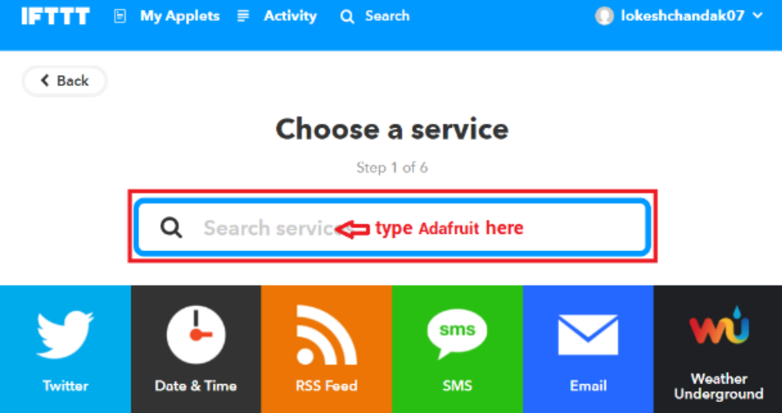
Fig 3.14 Searching Adafruit

After selecting Adafruit, choose action as shown in Fig 3.15,

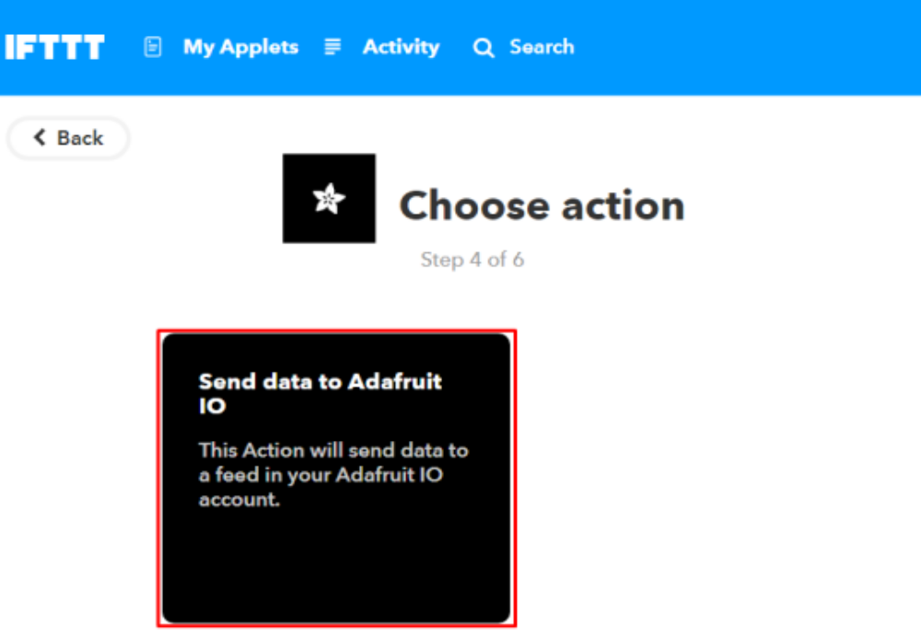
Fig 3.15 Sending Data to Adafruit IO
Now enter what data needed to send to which feed of Adafruit dashboard.
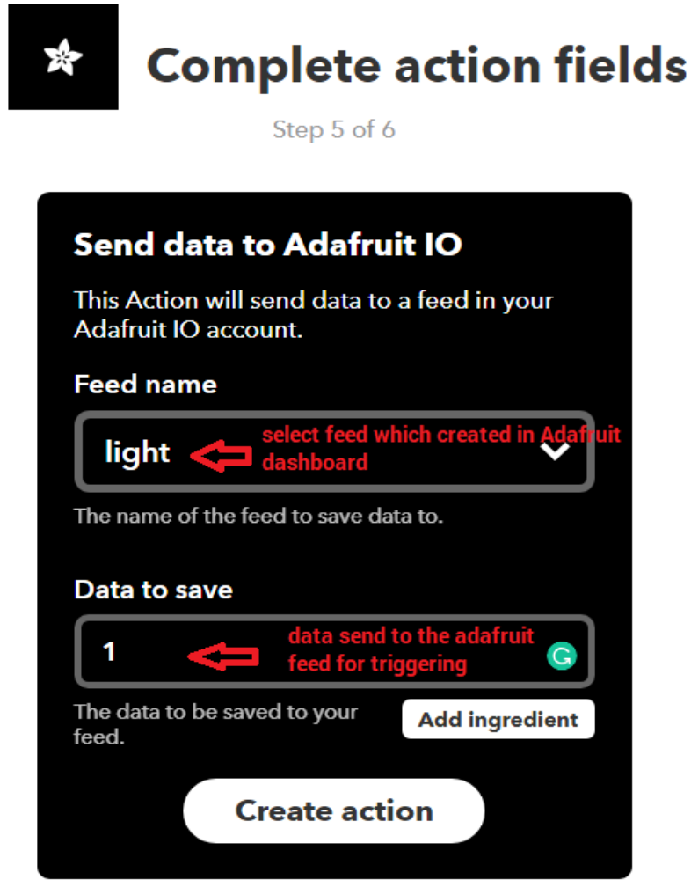
Fig 3.16 Completing action fields

Click on Create Action.
So, when Google Assistant is used on my mobile. This will trigger the event on Adafruit dashboard which is continuously monitored by the microcontroller (here NodeMCU). This microcontroller will take action as per the data change on the Adafruit dashboard.
3.3 BLOCK DIAGRAM
The block diagram of the Google assistant-controlled Home Automation is shown in the Fig 3.17.
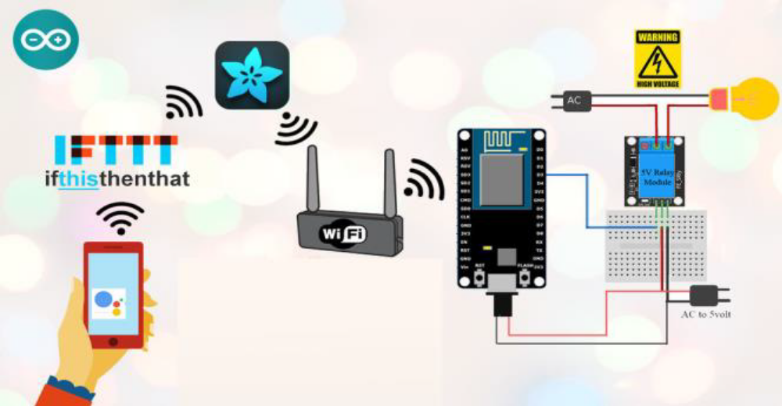
3.17 Block diagram of Google assistant-controlled Home automation.

In Google assistant-controlled home automation, first the user should have an Android smartphone with Google assistant installed in it. When the user gives commands to the Google assistant, the commands will be checked with the commands in the IFTTT website which are already set. Then the next step is setting up the virtual switches in Adafruit website. If the commands given by the user matches with the commands in the IFTTT website, then depending on that commands, the virtual switches in Adafruit will be turned ON or OFF. This will be sensed by the Node microcontroller and it will turn ON or OFF the relay depending on the commands. All this will be done over the Internet. In this, the relay will act as a switch and the Home appliances connected to the relay will be turned on or off. The number of Home appliances connected depends upon the number of relays.

3.4 TROUBLESHOOTING
There are a number of places that the connection between our voice and the light can break down. If the light isn't changing when the user speaks, there are a few things should be checked.
The light should be turned ON or OFF when the user toggles the switch on the Adafruit IO dashboard. If not, the ESP8266 is either not connecting to the server, not subscribing to the feed, or not checking for the correct string values.
Check the Serial Monitor output of the ESP8266 device to find out.
If the Google Assistant doesn’t hear the user properly, use the Google Allo app, users can see what the Assistant heard, or can directly type the phrase which the user want it to interpret. If the Google assistant doesn’t respond with the correct phrase, then Google account and IFTTT account aren't connected. Make sure that the same Google accounts for the Google assistant and IFTTT is used. If the Adafruit IO dashboard doesn’t update when the IFTTT applet triggers, then Adafruit IO account and IFTTT account aren't connected. Double check on IFTTT to make sure that both the accounts have been linked.

3.5 INTERFACING NODEMCU WITH RELAY
The interfacing diagram of NodeMCU with Relay module is shown in Fig 3.18. The +5v Vin pin of the NodeMCU is given to the Voltage pin of relay module. The ground pin of Node Microcontroller is connected to ground pin of the Relay module. The NodeMCU consists of 8 data pins, clock, reset, enable, transmitter, receiver, flash etc., If the 4-Channel relay is used, then the data pins D0, D1, D2, D3 are connected to the 4 data pins of the Relay in which D0 is used to control 1st relay, D1 is used to control the 2nd relay, D3 is used to control the 3rd relay and D4 is used to control the 4th relay. The output of the relay consists of 3 pins in which two of them are given to the output like bulb, fan etc., and the one is of no connection.

3.5.1 CONNECTION OF BULB TO RELAY MODULE
While connecting bulb with the relay module, one of the wires of the bulb is directly connected to the power supply, the other wire of the bulb will be given to the power supply through relay module as shown in the Fig 3.18.
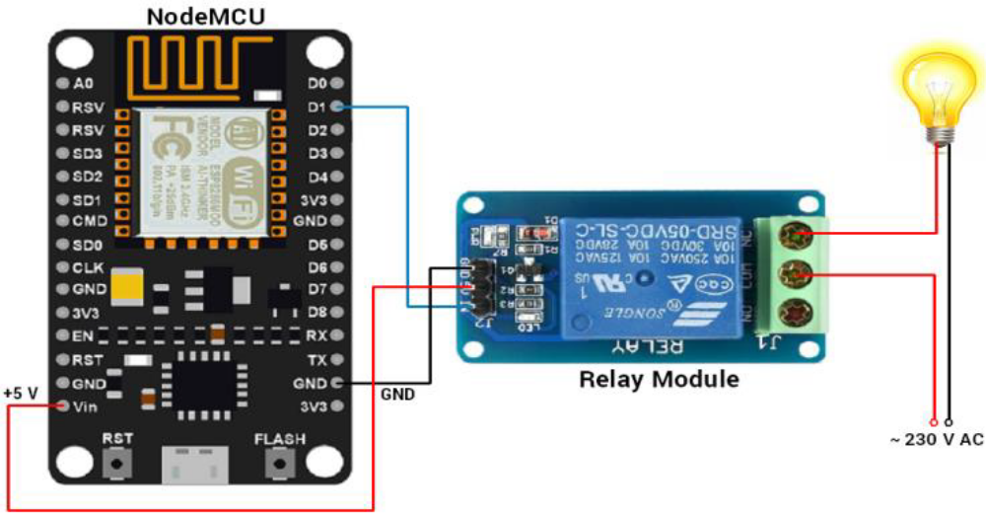
3.18 Interfacing Diagram of Node MCU (ESP8266) with Relay module.

CHAPTER – 4 IMPLEMENTATION

The Implementation of the project design can be divided into two sections; Hardware and Software implementations. The hardware implementation consists of the development of the main controller, sensor networks and the smart home while the software implementation focuses on the programming of the Node microcontroller using Arduino IDE.

4.1 HARDWARE REQUIREMENTS
1. NodeMCU – 32-bit ESP8266 development board with Wi-Fi SoC.
2. Relay module
3. One 15W Bulb
4. One 9V DC Fan

4.1.1 NODE MCU (ESP8266)
NodeMCU is an open source IoT platform, includes firmware which runs on the ESP8266 Wi-Fi Module from Espressif Systems, and hardware which is based on the ESP-12 module. The term “NodeMCU” by default refers to the firmware rather than the development kits. NodeMCU firmware was developed so that AT commands can be replaced with Lua scripting making the life of developers easier. The ESP8266 is a low-cost Wi-Fi chip with full TCP/IP stack and microcontroller capability produced by Shanghai-based Chinese manufacturer, Espressif. Fig 4.1 shows the NodeMCU (ESP8266) Development Board.

FEATURES OF NODE MCU (ESP8266):
1. Open-source
2. Interactive
3. Programmable
4. Low cost
5. Simple
6. Smart
7. WI-FI enabled
8. USB-TTL included
9. Plug & Play

SPECIFICATIONS OF NODE MCU (ESP8266):
- Developer : ESP8266 Opensource Community
- Type : Single-board microcontroller
- Operating system : XTOS
- CPU : ESP8266
- Memory : 128kBytes
- Storage : 4Mbytes
- Power By : USB
- Power Voltage : 3v ,5v (used with 3.3v Regulator inbuilt on Board using Pin VIN)
- Code : Arduino Cpp
- IDE Used : Arduino IDE
- 11. GPIO : 10
- ADVANTAGES OF NODE MCU (ESP8266):
- 1. Low energy consumption
- 2. Integrated support for WIFI network
- 3. Reduced size of the board
- 4. Low Cost
- PIN DIAGRAM OF NODE MCU: 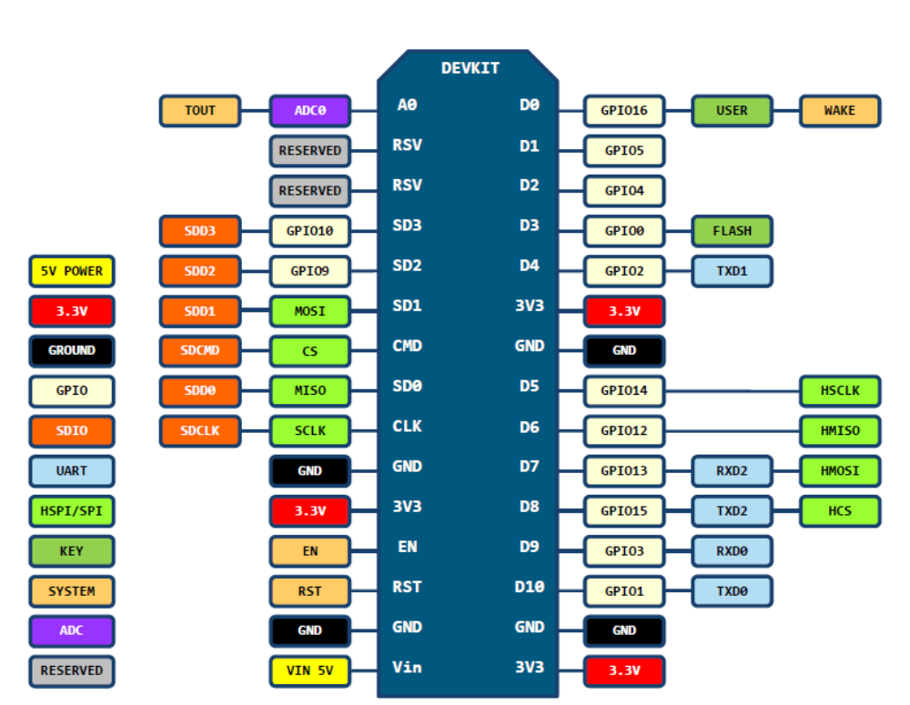
Fig 4.2 Pin Diagram of Node MCU
PROGRAMMING NODE MCU:
• Install the current upstream Arduino IDE at the 1.8 level or later. The current version is at the Arduino website.
• Start Arduino and open Preferences window.
• Enter https://arduino.esp8266.com/stable/package_esp8266com_index.json into Additional Board Manager URLs field. You can add multiple URLs, separating them with commas.

After Completion,
1. Data Cable of your Mobile Phone. Used in To Connect ESP8266 MCU NODE with PC.
2. After Install Drivers if Needed.
3. Check Which Number Is Assigned To your Board.
4. Open Arduino IDE.
5. Open Boards Manager from Tools > esp8266 Modules platform And Select NodeMCU 1.0(ESP-12E Module) board from Tools.
• Upload Using: Serial
• CPU Frequency: 80Mhz
• Flash Size: 4M
• Upload Speed: 115200
• PORT: Select Assign Port Only.
6. Upload Code.

4.1.2 RELAY MODULE
A 4-Channel Relay interface board allows us to control various appliances, and other equipment’s with large current. It can be controlled directly by Micro-controller (Arduino, Node MCU, Raspberry Pi, 8051, AVR, PIC, DSP, ARM, ARM, MSP430, TTL logic).
Specifications:
• 4-Channel Relay interface board, and each one needs 15-20mA Driver Current
• Both controlled by 12V and 5V input Voltage
• Equipped with high-current relay, AC250V 10A; DC30V 10A
• Standard interface that can be controlled directly by microcontroller.
• Opto-isolated inputs
• Indication LED’s for Relay output status.

A relay is an electromagnetic switch. It is activated when a small current of some microampere is applied. Normally, a relay is used in a circuit as a type of switch, an automatic switch. There are different types of relays and they operate at different voltages. When a circuit is built the voltage that will trigger it has to be considered. In this system the relay circuit is used to turn the appliances ON/OFF. The high/low signal is supplied from the NodeMCU microcontroller. When a low voltage is given to the relay of an appliance it is turned off and when a high voltage is given it is turned on. The relay circuit is to drive four appliances in the Home automation system. The number of appliances can be modified according to the user’s requirements.

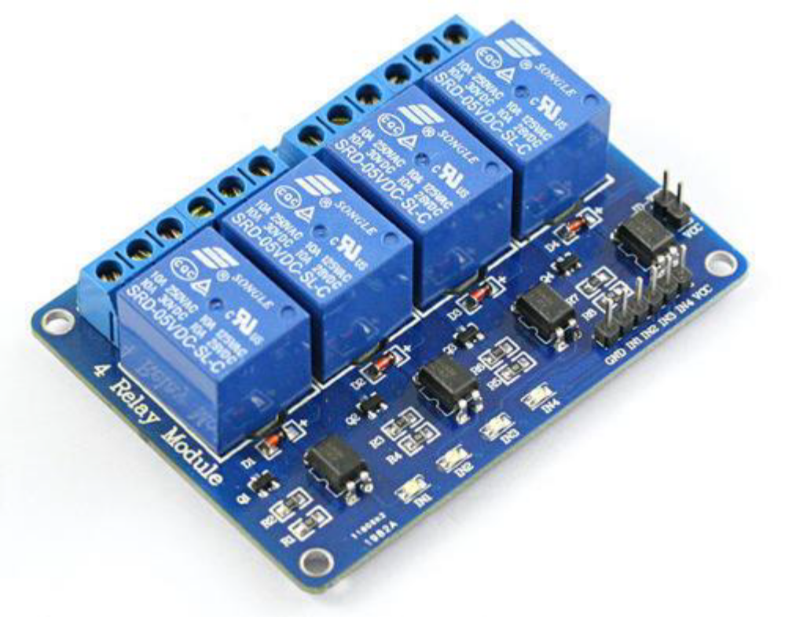
Fig 4.3 4 - CHANNEL RELAY

PIN DESCRIPTION:

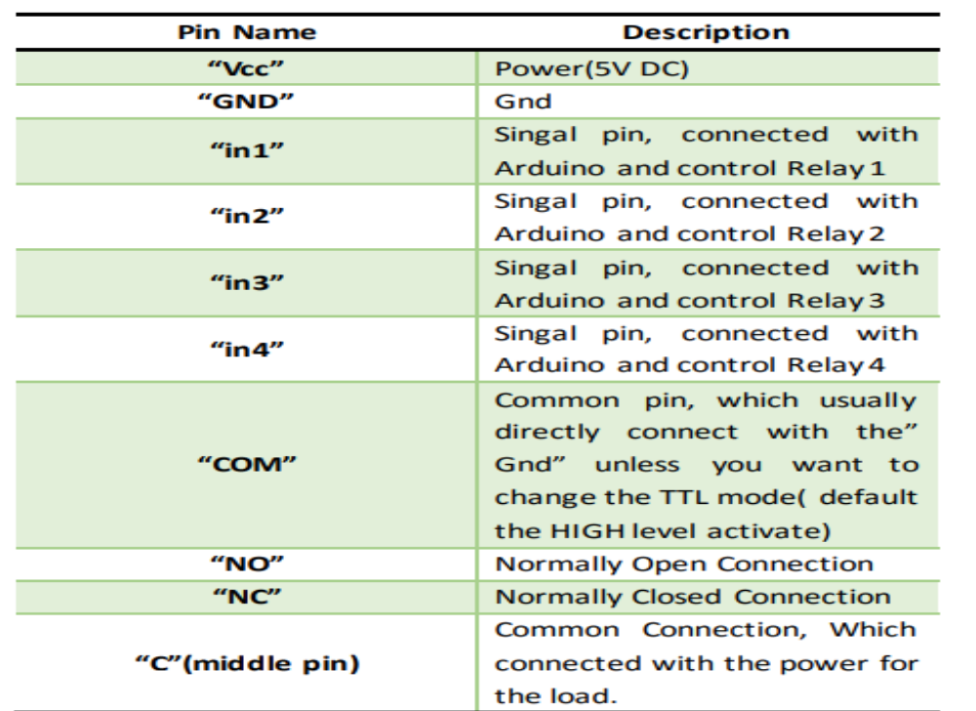
Fig 4.4 Pin description of 4-Channel Relay
ADVANTAGES:
1. Relays can switch AC and DC, transistors can only switch DC.
2. Relays can high voltages, transistors cannot.
3. Relays are a better choice for switching large currents(>5A).
4. Relays can switch many contacts at once.

4.2 SOFTWARE REQUIREMENTS
1. Google assistant application
2. Adafruit IO
3. IFTTT Service.
4. Arduino IDE

4.2.1 GOOGLE ASSISTANT
The Google Assistant is an Artificial Intelligence based Virtual assistant software which allows its users to control all the apps in their device. It allows the users to control and command most of the apps in their devices using voice commands. This provides more convenience to the people as they only have to command the google assistant thorough voice command. Fig 4.5 shows Google assistant.

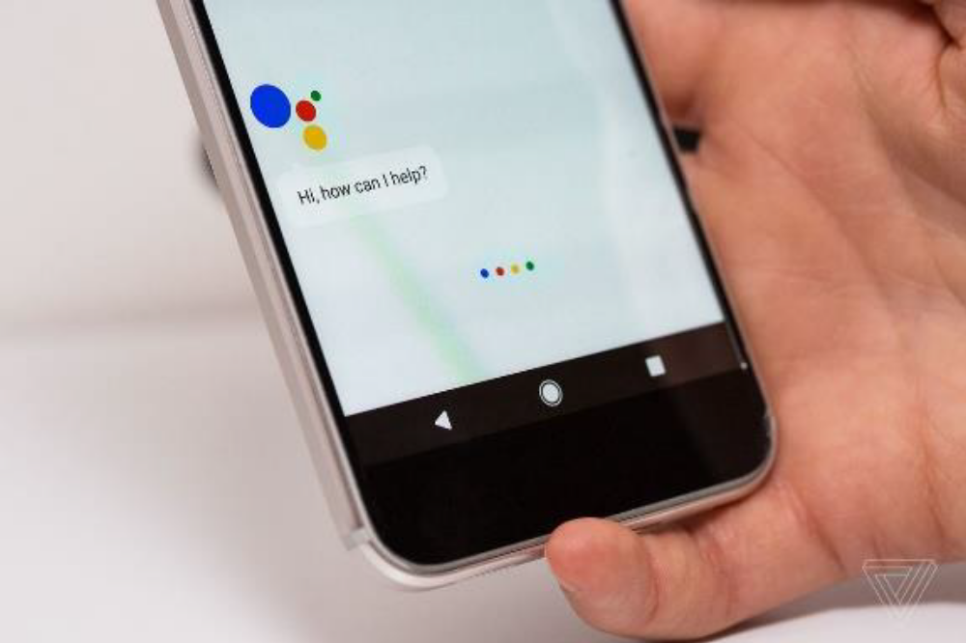
Fig 4.5 Google assistant

Google Assistant is an artificial intelligence-powered virtual assistant developed by Google that is primarily available on mobile and smart home devices. Unlike the company's previous virtual assistant, Google Now, Google Assistant can engage in two-way conversations. Assistant initially debuted in May 2016 as part of Google's messaging app Allo, and its voice
activated speaker Google Home. After a period of exclusivity on the Pixel and Pixel XL smartphones, it began to be deployed on other Android devices in February 2017, including third-party smartphones and Android Wear (now Wear OS), and was released as a standalone app on the iOS operating system in May 2017.
Alongside the announcement of a software development kit in April 2017, the Assistant has been, and is being, further extended to support a large variety of devices, including cars and third-party smart home appliances. The functionality of the Assistant can also be enhanced by third-party developers.
Users primarily interact with Google Assistant through natural voice, though keyboard input is also supported. In the same nature and manner as Google Now, the Assistant is able to search the Internet, schedule events and alarms, adjust hardware settings on the user's device, and show information from the user's Google account. Google has also announced that the Assistant will be able to identify objects and gather visual information through the device's camera, and support purchasing products and sending money, as well as identifying songs

4.2.2 ADAFRUIT IO
Adafruit IO is used to connect projects to Internet. It can handle and visualize multiple feed of data. Dashboards are a feature integrated into Adafruit IO which allow users to chart, graph, gauge, log, and display our data. Users can view their dashboards from anywhere in the world. Adafruit IO is used to control and react to the user’s data. It is a platform designed to display, respond, command, and interact with project's data. It also keeps our data private and secure for us. It's the internet of things - for everyone. Adafruit IO also allows to set up dashboards that let users directly manipulate or view the current value of each topic. Since it can be accessed from a web browser, it makes it the ideal hub for monitoring and controlling all of various IOT projects.

4.2.3 IFTTT
If This Then That, also known as IFTTT, is a free web-based service to create chains of simple conditional statements, called applets. An applet is triggered by changes that occur within other web services such as Gmail, Facebook, Telegram, Instagram, or Pinterest. For example, an applet may send an e-mail message if the user tweets using a hashtag, or copy a photo on Facebook to a user's archive if someone tags a user in a photo. IFTTT is an initialism for "If This Then That. In addition to the web-based application, the service runs on iOS and Android. IFTTT users created about 20 million recipes each day. All of the functionalities of the Do suite of apps have since been integrated into a redesigned IFTTT app.

4.2.4 ARDUINO IDE
The Arduino integrated development environment (IDE) is a cross-platform application (for Windows, macOS, Linux) that is written in the programming language Java. It is used to write and upload programs to Arduino compatible boards, but also, with the help of 3rd party cores, other vendor development boards.
The source code for the IDE is released under the GNU General Public License, version 2. The Arduino IDE supports the languages C and C++ using special rules of code structuring. The Arduino IDE supplies a software library from the Wiring project, which provides many common input and output procedures. User-written code only requires two basic functions, for starting the sketch and the main program loop, that are compiled and linked with a program stub main() into an executable cyclic executive program with the GNU toolchain, also included with the IDE distribution. The Arduino IDE employs the program avrdude to convert the executable code into a text file in hexadecimal encoding that is loaded into the Arduino board by a loader program in the board's firmware.

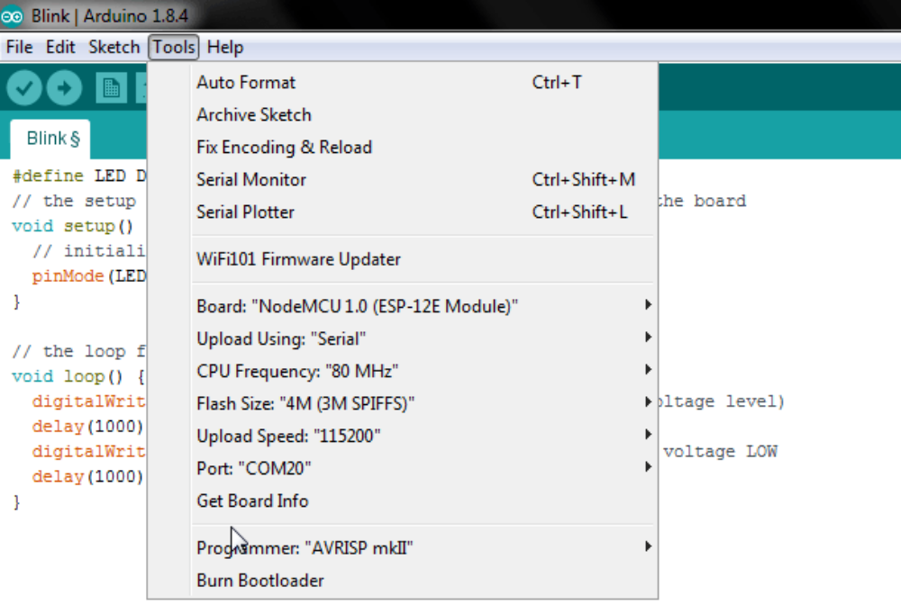
Fig 4.6 Arduino IDE

4.3 PROGRAM CODE

CHAPTER – 5
RESULT ANALYSIS
The output for Google assistant-controlled Home automation is shown below. Fig 5.1 shows the complete prototype implementation of the proposed system.
CHAPTER – 6
CONCLUSION AND FUTURE WORK
6.1 CONCLUSION
In this project, voice commands are given to the Google assistant. The voice commands for Google assistant have been added through IFTTT website and the Adafruit account is also linked to it. In this home automation, user have given commands to the Google assistant. Home appliances like Bulb, Fan and Motor etc., are controlled according to the given commands. The commands given through the Google assistant are decoded and then sent to the microcontroller and it control the relays. The device connected to the respective relay turned On or OFF as per the users request to the Google Assistant. The microcontroller used is NodeMCU (ESP8266) and the communication between the microcontroller and the application is established via Wi-Fi (Internet).
There has been tremendous growth in the home automation sector, and many reputed companies utilizing their opportunity to work with IFTTT to deliver an elegant way to connect families to their homes. Consumers are looking to secure their home environment in today’s unpredictable world, and the new Home automation service gives them the peace of mind that they need to protect their family’s well-being.
This project is about wireless home automation using Android mobile helps us to implement such a fantastic system in our home at a very reasonable price using cost-effective devices. Thus, it overcomes many problems like costs, inflexibility, security etc. In addition, will provide greater advantages like it decrease our energy costs, it improves home security. In addition, it is very convenient to use and will improve the comfort of our home. The project has proposed the idea of smart homes that can support a lot of home automation systems. C# programming language and Node microcontroller have been used to connect the sensors circuit to the home.
Also, in home and building automation systems, the use of wireless technologies gives several advantages which cannot be achieved by using a wired network.
1) Reduced installation costs.
2) Easy deployment, installation, and coverage.
3) System scalability and easy extension.
4) Aesthetical benefits.
5) Integration of mobile devices.
For all these reasons, wireless technology is not only an attractive choice in renovation and refurbishment, but also for new installations. 6.2 APPLICATIONS
• Lighting control system
• Appliance control with a smart grid
• Indoor positioning systems
• Home automation for elderly and disabled people
6.3 FUTURE WORK
There are a variety of enhancements that could be made to this system to achieve greater accuracy in sensing and detection.
a) There are a lot of other sensors that can be used to increase the security and control of the home like pressure sensor that can be put outside the home to detect that someone will enter the home.
b) Changing the way of the automated notifications by using the GSM module to make this system more professional.
c) A smart garage that can measure the length of the car and choose which block to put the car into it and it will navigate the car through the garage to make the parking easy for the homeowner in his garage.

WEBSITES

https://ifttt.com/discover
https://www.pocketlini.com/SmartHome/SmartHomenew
https://nodemcu.readthedocs.io/en/master
https://iobytes.wordpress.com/nodemcuinout/
https://assistant.google.com/intl/en_in/
https://www.arduino.cc/en/Guide/Environment

REFERENCE BOOKS
1. Internet of things – A Hands-on Approach, Arshdeep Bahga and Vijay Madishetti, University press, 2015, ISBN: 9788173719547
2. Advanced Microprocessors and Peripherals – A. K. Ray and K. M. Bhurchandani, MHE, 2nd edition, 2006.
3. Modern digital electronics – RP Jain – 4/e – MC GRAW HILL EDUCATION, 2010.
4. Electronics devices and circuits – Salivahanan, MC GRAW HILL EDUCATION, 4th edition, 2010

